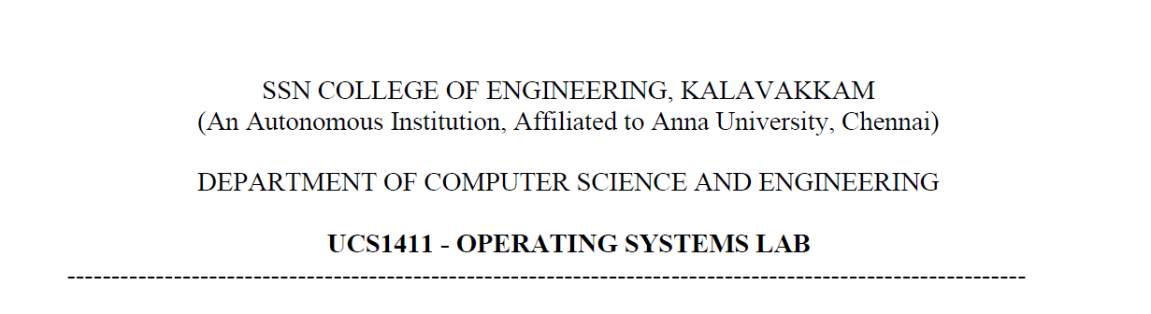

**LAB EXERCISE 1**

Name: Jayannthan P T

Dept: CSE ‘A’

Roll No.: 205001049

Develop a C program to understand the working of fork()

**Code:**

#include <stdio.h>

#include <unistd.h>

**int** main()

{

    printf("Before forking- this line is printed once\n\n");

**int** id = fork();

    printf("After forking\n");

    if (id == 0)

        printf("Child process underway- executed after parent\n\n");

    else

        printf("Parent process underway- executed first\n\n");

    return 0;

}

**Output:**

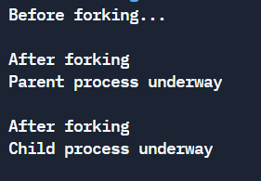

*Develop a C program using system calls to open a file, read the contents of the same, display it and close the file. Use command line arguments to pass the file name to the program*

**Code:**

#include <stdio.h>

#include <stdlib.h>

#include <unistd.h>

#include <fcntl.h>

**int** main(**int** argc, **char** *argv**[]**)

{

    if (argc > 2)

        printf("Too many arguements\n");

    else if (argc < 1)

        printf("Atleast one arguement required\n");

    else

    {

**int** file_descriptor = open(argv[1], O_RDONLY);

        if (file_descriptor == -1)

            printf("File does not exist\n");

        else

        {

            printf("File descriptor is: %d\n", file_descriptor);

**char** contents[100];

            read(file_descriptor, contents, 100);

            printf("File contents : %s\n", contents);

            close(file_descriptor);

        }

    }

    return 0;

}

**Output:**

